

Draw It or Lose It

CS 230 Project Software Design Template
Version 1.0

Table of Contents

CS 230 Project Software Design Template 1
Table of Contents 2
Document Revision History 2
Executive Summary 3
Requirements 3
Design Constraints 3
System Architecture View 3
Domain Model 3
Evaluation 4
Recommendations 5

Document Revision History

Version | Date | Author | Comments
1.0 | 9/26/2025 | Gwen Krezel | Edited template

Executive Summary

Draw It or Lose It is an application that the client, The Gaming Room, has consulted Creative Technology Solutions (CTS) to aid in its development. The proposed application will be a web app where a given number of teams of players compete to guess what is being drawn. The drawn images will be fetched from a stock library of drawings that gradually become more complete.

Requirements

< Please note: While this section is not being assessed, it will support your outline of the design constraints below. In your summary, identify each of the client’s business and technical requirements in a clear and concise manner.>
(I would like to complete this section but as I am behind in school work and short on time at the moment, I need to spend more time on the other sections.)

Design Constraints

Per the client’s request, the application must meet the following general design constraints:
- The Game names and Team names must be unique in order to avoid having duplicate names.
- Each instance of a Game must be able to manage one or more connected teams.
- Each team must be able to support multiple connected players.
- Only one instance of a game can exist in memory at any given time.

Because the application will be deployed as a web application, the following constraints must be considered:
- The frontend of the application must be developed in a language or framework that can either be compiled into HTML, CSS, and Javascript in order to be usable on modern browsers, or the application must have a backend that can serve pre-rendered HTML data to the client.
- The frontend must be able to interface with the backend through a secure HTTPS connection.

System Architecture View

Please note: There is nothing required here for these projects, but this section serves as a reminder that describing the system and subsystem architecture present in the application, including physical components or tiers, may be required for other projects. A logical topology of the communication and storage aspects is also necessary to understand the overall architecture and should be provided.

(I would like to complete this section but as I am behind in school work and short on time at the moment,
I need to spend more time on the other sections.)

Domain Model

The application uses a standard object oriented design pattern along with an instance of the singleton pattern.

The Game, Team, and Player classes all inherit the Entity class. The Entity class is designed to designate a unique piece of data in memory using an ID. Because the Game, Team, and Player classes inherit Entity, they also possess the Entity class’ unique behavior.

The GameService class uses the singleton pattern to ensure there is exactly one instance of the class in memory. GameService has a zero to many relationship with the Game class, which has a zero to many relationship with the Team class, which has a zero to many relationship with the Player class. This hierarchy allows for creating separate “rooms” in which a game takes place and allows for a localized uniqueness of entities in each level of separation. This means that two separate games can have teams with the same name, but one single game cannot have multiple teams with the same name.

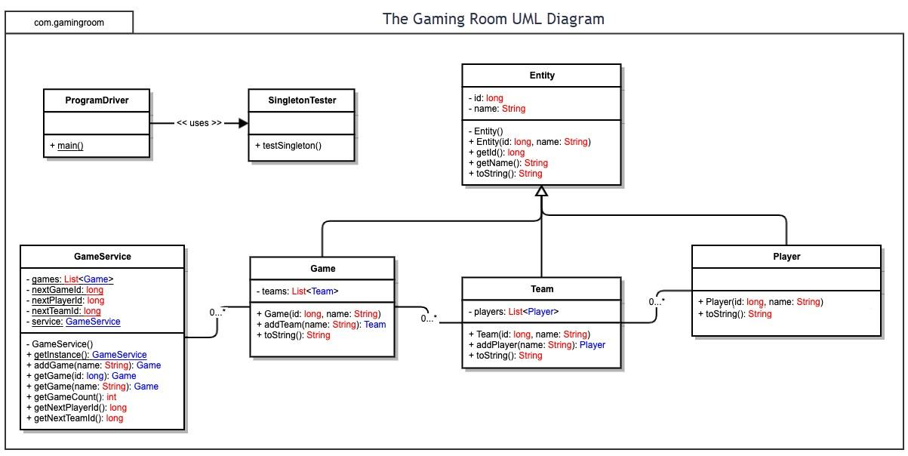

Evaluation

Using your experience to evaluate the characteristics, advantages, and weaknesses of each operating platform (Linux, Mac, and Windows) as well as mobile devices, consider the requirements outlined below and articulate your findings for each. As you complete the table, keep in mind your client’s requirements and look at the situation holistically, as it all has to work together.

In each cell, remove the bracketed prompt and write your own paragraph response covering the indicated information.

Development Requirements | Mac | Linux | Windows | Mobile Devices
Server Side | There are no common advantages to hosting a server on a OSX based machine. Hardware that natively uses OSX is usually much more expensive than other hardware and operating systems. | Linux is a commonly used platform for hosting a variety of servers, and the operating system is free to use, and there are many different flavors of Linux more suited for certain tasks. Many Linux distributions include a headless version as well. | Windows is also a commonly used platform for hosting servers because of the range of software and services developed for the platform. Unlike Linux, Windows is not free. | Most mobile devices do not possess the hardware needed to host a server and should not be used for this purpose.
Client Side | Mac uses the Safari web browser by default. While Safari adheres to most web standards for HTML, CSS, and Javascript, there are some aspects that may differ from other modern web browsers that should be considered during development | Linux doesn’t have a single default browser for every distribution, so cross compatibility between many different browsers should be considered. | By default, Windows uses the Edge browser, which is a Chromium based browser. Many of the commonly used web browsers will be cross compatible with Edge, but care should be taken with some less commonly used CSS functions. | Most mobile devices use either Chrome or Safari by default, so many of the same considerations that would be taken for other platforms should apply to mobile platforms as well.
Development Tools | Java is a language that can be used on almost any platform, so language specific limitations should not be a problem.  Development tools like Eclipse or Visual Studio Code can be used on most platforms and interface with version/source control very easily. | Java is a language that can be used on almost any platform, so language specific limitations should not be a problem.  Development tools like Eclipse or Visual Studio Code can be used on most platforms and interface with version/source control very easily | Java is a language that can be used on almost any platform, so language specific limitations should not be a problem.  Development tools like Eclipse or Visual Studio Code can be used on most platforms and interface with version/source control very easily | Java is a language that can be used on almost any platform, so language specific limitations should not be a problem.  Development tools like Eclipse or Visual Studio Code can be used on most platforms and interface with version/source control very easily

Recommendations

Analyze the characteristics of and techniques specific to various systems architectures and make a recommendation to The Gaming Room. Specifically, address the following:

- Operating Platform: As the application has an unknown number of concurrent users, a scalable server system should be used or a dedicated server hosting service should be utilized. An x86-64 based system running any Linux distribution or Windows should prove adequate.

- Operating Systems Architectures: Linux or Windows would both be sufficient for the application’s backend. If the client ever intends to utilize the Azure software suite into their workflow, Windows would be the better option as there are many development tools that are more specific to Windows systems.

- Storage Management: A structured database would be most suited to the storage of user information for this application because there is no need for a high volume of CRUD operations.
MS SQL Server is a common choice for this use case, but open source options such as PostgresSQL can also be utilized.

- Memory Management: Java utilizes automatic garbage collection, meaning memory that is no longer in use will be automatically unallocated. Java applications have the potential to use a lot of memory, so having a sufficient amount of RAM installed and allocating more RAM to the running Java process should be considered.

- Distributed Systems and Networks: Utilizing a server hosting service would be ideal for the client, as many server hosting services have redundancies to prevent outages or data loss. As HTTPS is a very commonly used protocol for sending and receiving data securely, there should be no extra considerations needed for connectivity purposes.

- Security: A standard authorization protocol such as OAuth 2.0 should be implemented to ensure users are authorized to perform various actions and access sensitive information. The application should also properly secure exposed endpoints to ensure unauthorized requests are not made and endpoints should also be able to detect and prevent DOS and DDOS attacks. The operating system should have a properly configured firewall to prevent the server from becoming compromised.

